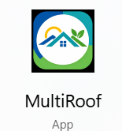Sequence Diagram of the LoD 2.2 CityJSON Generation Process
The diagram shows the sequence from clicking "Generate LoD 2.2 CityJSON" until the .city.jsonl output file is generated.
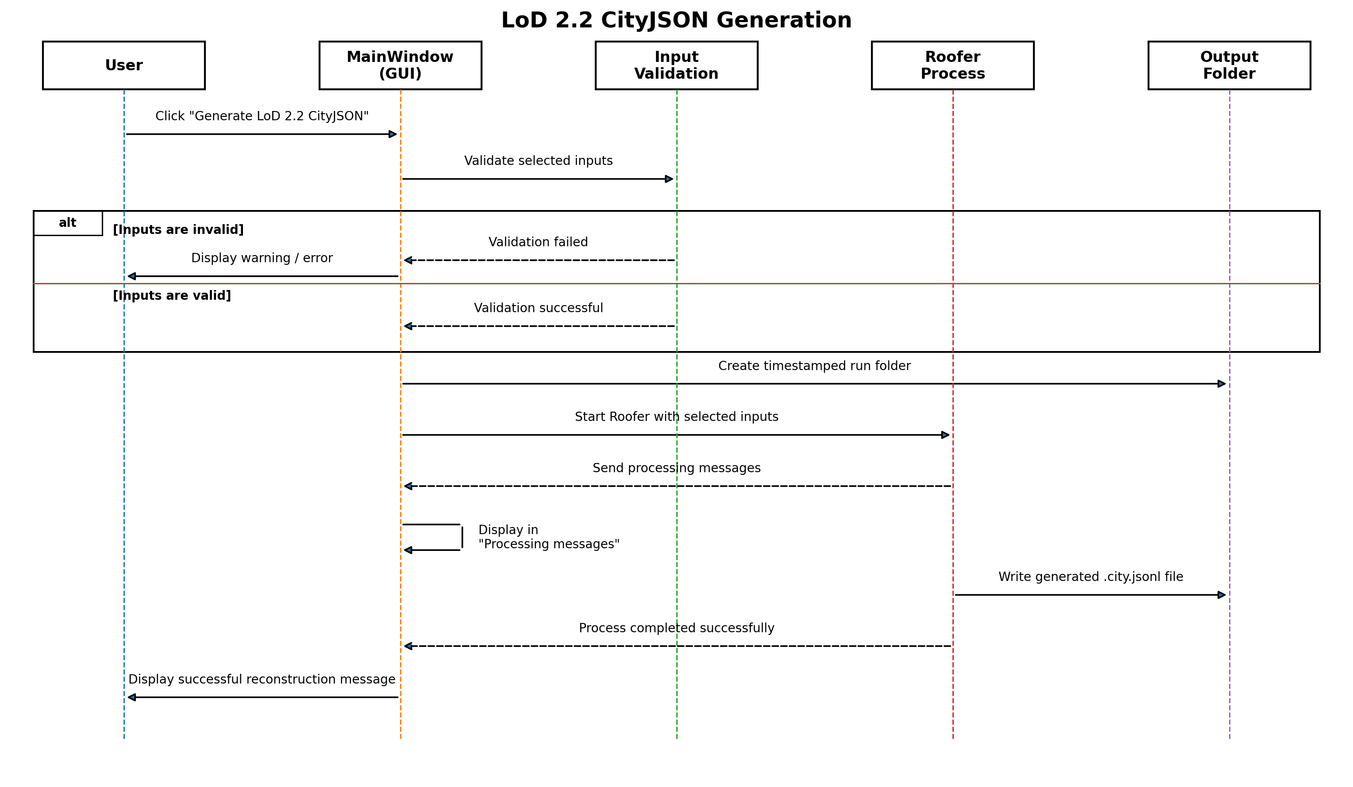
Figure 1. Sequence diagram of the LoD 2.2 CityJSON generation process.

